Calculus 2 Lecture 6.2: Derivatives of Inverse Functions

Inverse functions
For a one-to-one function (Must pass horizontal line test,one input-one output), 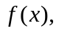 an inverse,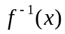, can be found.

NOTE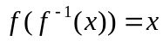 a function undoes an inverse of a function

To get an inverse of a function switch the x and y

Example
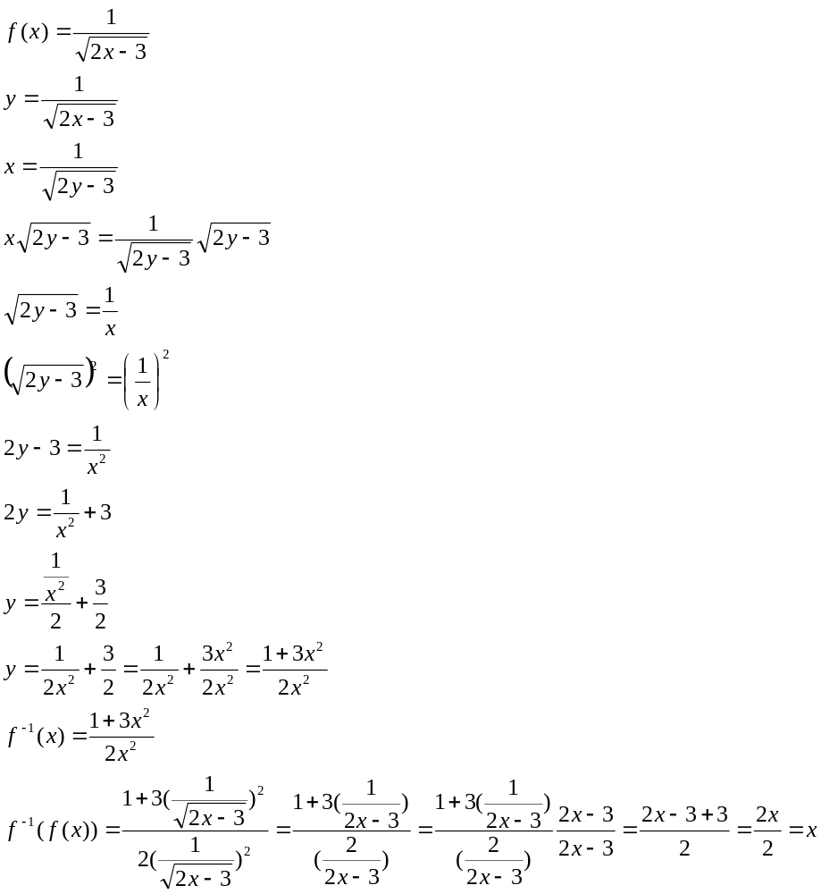
Inverse functions
NOTE
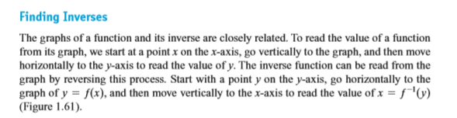
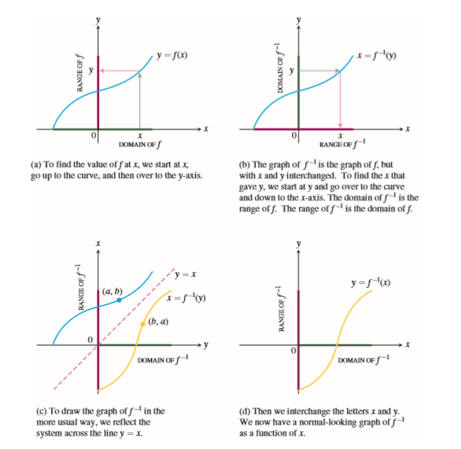
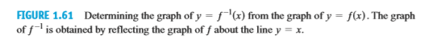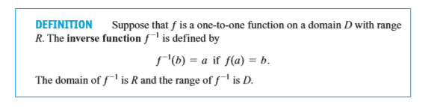

Finding the Derivative of an inverse function
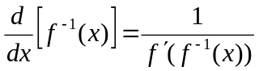 or 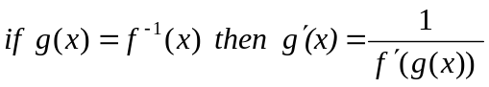

Example
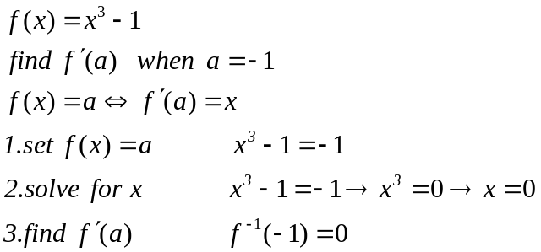
Example
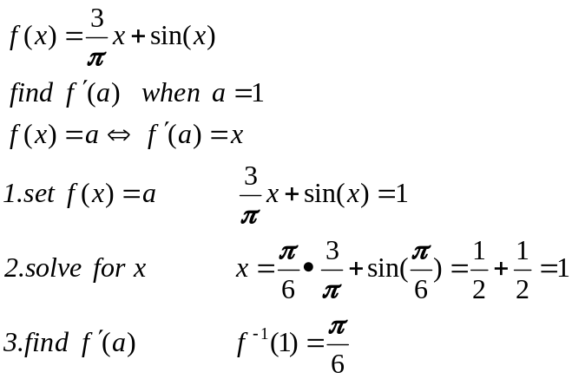

Example

Example
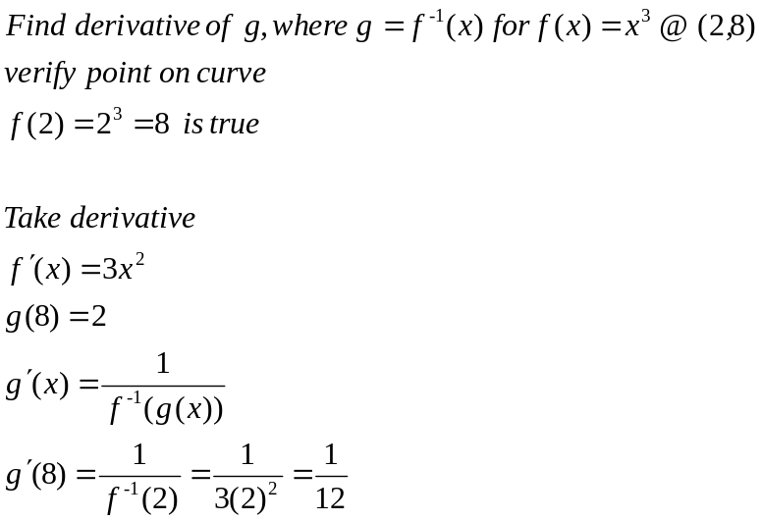
Example
